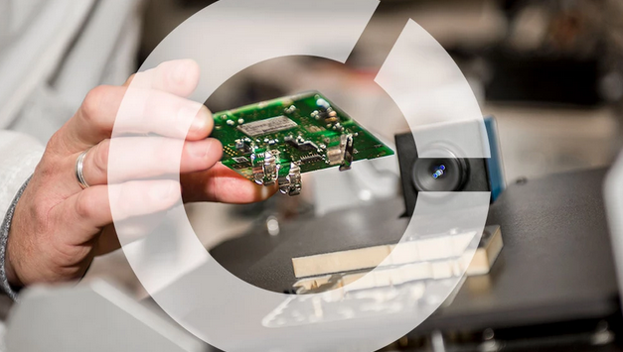

|  |
| --- |
|  |
| Project Report Document  Indoor Climate Control |
| |  |  |  | | --- | --- | --- | | Team x | 26-Jun-22 | T2-CB01 project | |

Author : Victor Covalciuc

Contents

Document history 2

Terms, Abbreviations 2

Summary 3

1. Introduction 3

2. Project overview 3

2.1. About the company 3

2.2. About the system 3

3. Procedure and Results 4

4. Discussion/validation (optional) 4

5. Conclusion(s) and Recommendation(s) 4

6. References / Literature list 4

7. Appendix (attachment) 4

List of Figures

**No table of figures entries found.**

List of Tables

**No table of figures entries found.**

# Document history

|  |  |  |  |  |  |
| --- | --- | --- | --- | --- | --- |
| **Version** | **Date** | **Status** | **Author** | **Description** | **Remarks** |
| 0.1 | 2020-Jun-15 | Draft | Xxx | Creation |  |
| 0.2 | 2020-Sept-01 | Draft | xxx | Add state machine diagram |  |
|  |  |  |  |  |  |
|  |  |  |  |  |  |

­­

# Terms, Abbreviations

|  |  |
| --- | --- |
|  |  |
| SDD | System Design Document |
|  |  |

# Summary

The informative summary is maximum one page long, and summarizes the entire report. You can only write the summary after you have completed the report.

# Introduction

The introduction is the first chapter of your report, but is certainly not firstly written, because at the beginning of your project you know too little to be able to write a good introduction! But after a few months, you are inclined to forget that the reader is not working on the project together with you and that things that are very clear for you, for him in the meantime are new and unknown. To avoid this (or restoring this) it is good to ask a fellow student to read your introduction.

The introduction should give the reader the first, global information about the project; the reader is prepared for reading the rest. There must therefore be at least information about the company, the problems, the project and the relevance of the project, and already a short indication of the followed strategy. The reader should be encouraged to read the report; so start with a catchy opening sentence, for example a compelling question, an equation, or a spectacular story (anecdote

In the last paragraph of the introduction: tell the reader what he can find in every chapter. As follows: Chapter 2 provides information about the company, Chapter 3 gives all the details about the assignment, Chapter 4 describes ….

# Project overview

In this chapter you give all the details about your project. The reader at the end knows everything about the following areas:

* What is the purpose of the assignment? What does the client hope to achieve with it? What is the desired end situation?
* What are the constraints for your assignment?
* Which methodology will you use? (methods, tools, procedures, rules)
* How are you going to phase you assignment?
* What research strategies do you need to execute the assignment? In which phase? (ref: <http://ictresearchmethods.nl/Main_Page> )

In this chapter you clearly describe what does belong to and does not belong to your project. Should you use a particular programming language or may you choose the programming language yourself, do you need to write a manual, or should you also install a system or develop a design only? Also if the company wants you to use a certain method or to apply a specific (ZigBee, Agile development…) the reader can find it here.

It is very important that you describe how the problems are tackeled and solved. For that reason you have to use the DOT framework. This framework describes the five different strategies you can use for your assignment (Library, Field, Workshop, Showroom, Lab).

# About the company

# About the system

# Procedure and Results

In this chapter you describe **what** you've done and **how**, and especially **why**. You describe what systematic way you have followed from the beginning to the end product(s). Usually this chapter is called Results, but you are free to choose your own title.

This chapter is the largest part of the report. For readability you can separate it in sections and subsections or you can make more than one chapter to describe your work. You are free to choose how you structure this part. Usually your structure is a chronological structure that follows the phasing you described in chapter 3 (your project overview)..

# Discussion/validation (optional)

This is an optional chapter intended to interpret and discuss the meaning of your results. Most assignments do not need a lot of discussion, so you can write this directly in the Conclusion chapter.

The present tense is normally used for this. You can use past tense to summarise your findings.

# Conclusion(s) and Recommendation(s)

In your conclusion chapter you can summarise your findings and explain or interpret what the results mean. You look back at the initial problem and validate if your solution(s) solved the problem. If your results need a lot of interpretation, it is better to create a chapter “Discussion” before this chapter.

If you have recommendations for further research on the topic you investigated, you can state this here.

The reader should be able to understand this chapter even when he or she only read the introduction chapter! The reader who has read the whole report, should encounter no new information in this last chapter, indeed: he must be able to predict its content!

This last chapter has no figures or enumerations. The maximum length is one page. A combination of tenses can be used to highlight past research and future directions.

# References / Literature list

You can list books, magazines and websites and other sources studied during your assignment. Make sure you mention recent information sources, in such a way that the interested reader may consult the same sources.

References have to be used according to APA standards. This means that both the reference list and the references themselves need to follow the APA guidelines (APA, 2013, http://www.apastyle.org).

# Appendix (attachment)

All attachments are numbered with Roman numerals or with capital letters, and have an informative. The information in an annex supplements the report, but the reader must be able to read the main report (the report without the attachments) completely independently of the attachments.

One of the attachments of your report can be your Project Plan.